**Hanzla saeed**

**472684**

**Section C**

**Lab manual 9(Home Task)**

**Q#1**

#include <bits/stdc++.h>

using namespace std;

double determinant(double matrix[3][3]) {

return matrix[0][0] * (matrix[1][1] * matrix[2][2] - matrix[1][2] * matrix[2][1]) -

matrix[0][1] * (matrix[1][0] * matrix[2][2] - matrix[1][2] * matrix[2][0]) +

matrix[0][2] * (matrix[1][0] * matrix[2][1] - matrix[1][1] * matrix[2][0]);

}

void adjoint(double matrix[3][3], double adj[3][3]) {

for (int i = 0; i < 3; ++i) {

for (int j = 0; j < 3; ++j) {

int sign = ((i + j) % 2 == 0) ? 1 : -1;

adj[j][i] = sign * (matrix[(i + 1) % 3][(j + 1) % 3] * matrix[(i + 2) % 3][(j + 2) % 3] -

matrix[(i + 1) % 3][(j + 2) % 3] * matrix[(i + 2) % 3][(j + 1) % 3]);

}

}

}

bool inverse(double matrix[3][3], double inv[3][3]) {

double det = determinant(matrix);

if (det == 0) {

cout << "Inverse cannot be calculated as the determinant is 0." << endl;

return false;

}

double adj[3][3];

adjoint(matrix, adj);

for (int i = 0; i < 3; ++i) {

for (int j = 0; j < 3; ++j) {

inv[i][j] = adj[i][j] / det;

}

}

return true;

}

int main() {

double matrix[3][3];

double inv[3][3];

cout << "Enter the elements of the 3x3 matrix :-" << endl;

for (int i = 0; i < 3; ++i) {

for (int j = 0; j < 3; ++j) {

cout << "Enter the element of the matrix["<<i<<"]["<<j<<"] :";

cin >> matrix[i][j];

}

}

if (inverse(matrix, inv)) {

cout << "The inverse of the matrix is:" << endl;

for (int i = 0; i < 3; ++i) {

for (int j = 0; j < 3; ++j) {

cout << inv[i][j] << " ";

}

cout << endl;

}

}

return 0;

}

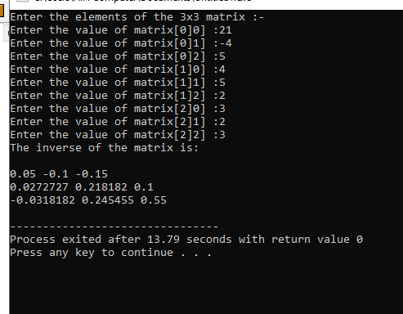

The End

**---------------------------------------------------------------------**